

STATEMENT OF ADVICE

Financial Planning Strategy
Prepared for:

Peter Magennis & Janelle Haslam
Of

42 Stanley Street

Black Rock VIC 3193

Mobile: 0412 677 348 (Peter)
Mobile: 0438 366 624 (Janelle)

Email: peter@ufoplastics.com.au
janelle@ufoplastics.com.au

Prepared on:

6th December 2017

By your Adviser:

Andrew Lord B Bus (Acc), Dip FS (Fin Plan)

Lakeside Financial

Level 1, 99 Bay Street
Brighton VIC 3186

Ph: 03 9596 5111 Fax: 03 9596 3222

Email: andrew.lord@lakesidefinancial.com.au
Authorised Representative # 324798
Pareto Group Pty Ltd
ABN 11 155 278 078 Australian Financial Services Licensee No. 418700
1/99 Bay Street, Brighton, Vic, 3186
Ph: 03 9596 5111 Fax: 03 9596 3222
What this document is about
This Statement of Advice (or SoA) is an important document.
- It provides you with information about our advice so you can make a decision about implementing the advice.
- It should be read in conjunction with other documents such as Product Disclosure Statements and our Financial Services Guide.

What to do after reading this Statement of Advice
Please contact us.
- If you have any questions.
- If we have omitted, overlooked or incorrectly understood any of your relevant circumstances.
- When you are ready to implement the recommendations.
- Or, if you decide you want to do something else and need our advice or assistance.
6/12/2017

Peter Magennis & Janelle Haslam
42 Stanley Street
BLACK ROCK VIC 3193

Dear Peter & Janelle,

I am pleased to enclose your Statement of Advice (SoA).

It is an important document that you should read and understand before making a decision to proceed further.

We have based the strategies and recommendations in this document on our understanding of your current personal and financial position. If any of this information does not reflect any part of your current position, goals and objectives please advise us immediately and we will make the necessary changes.

The SoA sets out our recommended strategies to address your needs, together with a recommended course of action to implement these strategies.

When you are ready to proceed, we would be very happy to help you with the implementation of the advice, including the completion and lodgement of application forms and other documents.

Please note, our recommendations in this Statement of Advice are valid for 30 days from the date on the cover of this document. If your circumstances change before you implement our recommendations, or if you don’t act on them within 30 days, they may no longer be appropriate for you. If that happens, please ask us to review your situation again before you take any action.

Once implemented, we should review your situation on a regular basis to ensure we make the most of any changes that may impact on the strategies I have recommended for you.

Yours sincerely,

Andrew Lord

B Bus (Acc), Dip FS (Fin Plan)
Authorised Representative No 324798 of
Pareto Group Pty Ltd
Table of Contents

Purpose of this document 4
Timeframe for our advice 4
Check for accuracy 4
Limitations of our advice 4
Introduction 6
The Scope of Our Advice 6
Your Adviser 7
The Planning Process 7
Executive Summary 8
Your Goals and Objectives 8
Personal Information 9
Personal Details 9
Estate Planning 9
Estate Planning 10
Wills and Testamentary Trusts 10
Non Estate Assets 12
What is paid to your adviser 14
Plan Fee 14

Purpose of this document

The following Statement of Advice (SoA) is an outline of the financial plan discussed with your financial planner. It details the recommendations needed to execute your plan and achieve your financial objectives.

Timeframe for our advice

Our recommendations in this SoA are valid for 30 days from the preparation date on the cover of this document. If your circumstances change before you implement our recommendations, or if you don’t act on them within 30 days, they may no longer be appropriate for you. If that happens, please ask us to review your situation before taking any action.

Check for accuracy

This SoA is based on the information you provided. Please read the document carefully, checking that your details are correct and that no important facts are missing. If anything is wrong or missing, please let us know immediately—otherwise our advice may be based on incorrect information and may not be right for you.

Limitations of our advice

We cannot give advice on:
- Trust or business structures | - Direct share or property purchases
- Taxation | - Legal matters
- General insurance

Please don’t consider any of this document’s recommendations to be advice in any of these areas. If you need advice in these areas, please see a qualified professional in that field.
Assumptions we've made

When giving advice, we make certain assumptions to demonstrate how the advice could affect your financial situation. We've based our advice on economic information and legislation that was current when we prepared your SoA.

Introduction

You are entitled to receive a Statement of Advice (SoA) whenever we provide you with any personal financial advice. Personal financial advice is advice that takes into account any one or more of your objectives, financial situation and needs.

This SoA is a record of the personal financial advice provided to you and includes information on the basis on which this advice is given, information about remuneration including fees, commissions, any other benefits and any interests, relationships or associations which might influence the making of the advice.

The Scope of Our Advice

In this statement of advice, the main focus is on:

- Estate Planning

This advice is based on information we have obtained from you. You must ensure the information is accurate and complete. Otherwise, this advice may be based on inaccurate or incomplete information relating to your investment objectives, financial situation or needs. You must therefore assess whether the advice is appropriate, in the light of your own individual investment objectives, financial situation or needs.

You recognise in each of the areas of advice we provide, we only provide advice to the extent we are able to under the relevant legislation.

Your Adviser

At any time should you have any questions or concerns, in the first instance please contact your adviser Andrew Lord on (03) 9596 5111.

Andrew Lord is authorised to represent Pareto Group Pty Ltd. Should you wish to discuss matters of concern about your adviser or the advice you have received please contact us on 03 9596 5111.

The Planning Process

Peter & Janelle, Financial Planning is a process to help you reach both your Personal and Financial Goals and Objectives. In order to achieve this we jointly need to undertake a number of tasks, including:

- Confirm your personal goals and lifestyle objectives;
- Quantify the resources required to meet your goals and objectives;
- Identify any gaps in your current plans and your stated goals and objectives;
- Conduct a regular review of the strategies we put into effect to ensure they keep pace with your changing needs & legislative changes .

Executive Summary

In this plan our advice considers the following areas of your financial circumstances.

Your Goals and Objectives
After our discussions I have listed below what we agreed were your key goals and objectives. The points listed below form the basis of the plan I have prepared, and therefore you should read them carefully now to ensure that we have an accurate foundation on which to proceed. If there are any modifications required, please advise us prior to the commencement of your financial plan.

Your goals and objectives are to:

- Provide an extra layer of protection for the assets you leave behind upon death.
- Control the manner in which your wealth will be distributed after your death.
- Place your future assets under the most tax effective ownership structure.

Personal Information

During our discussions and from the information you have provided, your Personal Details can be summarised as follows:

Personal Details
Title |  | Mr |  | Mrs
First Name |  | Peter |  | Janelle
Surname |  | Magennis |  | Haslam
Gender |  | M |  | F
Date of Birth |  | 30/11/1966 |  | 24/05/1971
Age Last Birthday |  | 51 |  | 46
Marital Status |  | De Facto |  | De Facto

Estate Planning
 |  |  | Peter |  | Janelle
Do you have a Current Will? |  |  | Yes |  | Yes
Do you have Current Powers of Attorney? |  |  | Yes |  | Yes
Do you have a Testamentary Trust? |  |  | No |  | No

Estate Planning
Although considerable emphasis is placed on wealth creation and protection, a vital aspect of your financial strategy is the control of the manner in which your wealth will be distributed after your death.

The expression “Estate planning” represents the concept of the planning and documentation of your wishes for the distribution of your wealth following death, whether the assets are held personally or controlled by related entities such as trusts or companies.

Estate planning is a specialised area, and it is important that you obtain professional advice in relation to all areas of your estate plan. However we outline below some of the issues you should consider in designing your estate plan.

Wills and Testamentary Trusts

A Will is the first step in ensuring that the distribution of your estate is actioned in accordance with your wishes. If you die without a Will (intestate), it may be that a court will control both the manner of distribution of your estate and the persons to whom your estate is distributed, and this can cause unnecessary distress.

Both of you currently have basic Wills in place.

Recommendation:

- We have an arrangement with Lakeside Lawyers Pty Ltd who can assist with the implementation of appropriate Wills as soon as possible.

It is important to ensure your Will:
  - Nominates executors (and substitute executors) who are likely to survive you and who clearly understand your wishes.
  - Nominates beneficiaries in relation to every segment of your estate and nominates alternative beneficiaries should your primary beneficiaries predecease you.
  - Bequeaths monetary value or a percentage of your estate rather than a specific asset, as there is the risk that an asset may not be in existence at the time of distribution of the estate.
  - Includes provision for the establishment of a testamentary trust, which can be a tax effective tool for distributing your estate.

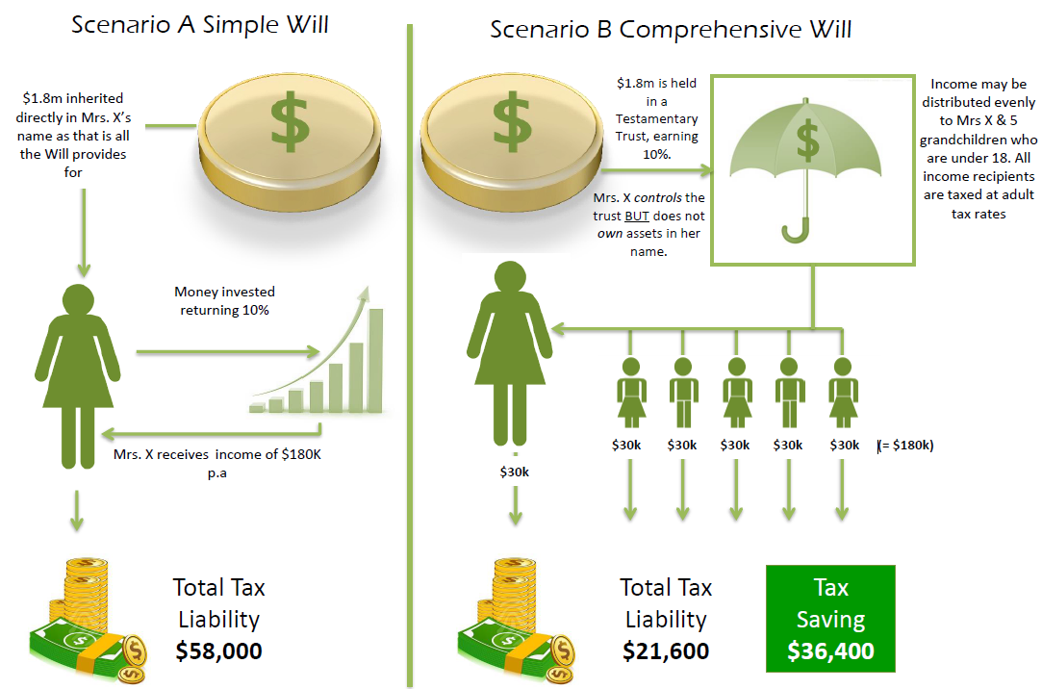
For an illustration of inner workings of a Will that allows for Testamentary Trust Provisions, please refer to the diagram below.
Disadvantages of a simple Will:
➢ Tax ineffective
➢ If Mrs. X starts a new marriage OR de facto relationship 50% of the assets may be up for grabs
➢ No opportunities to adapt to changing financial or lifestyle circumstances
➢ In the event of Mrs. X dying shortly after Mr. Y, the money would go straight to the children which may not be the best outcome:
▪ if they are high income earners
▪ if there is a threat of business litigation (immediately or in the future)
▪ should a relationship fail as 50% as assets would be caught up in any settlements or disputes

Benefits:
- Peace of mind, knowing all your wishes are detailed to be carried out, and plans articulated for your immediate family to be adequately provided for in the event of your death.
- If your Will incorporates a testamentary trust, your assets would pass into a discretionary trust (or multiple trusts) and be held for the benefit of your beneficiaries, (rather than directly by them).
- This could be determined on an annual basis having regard to each beneficiary's personal income and taxation circumstances (importantly, income distributed from a testamentary trust to minors is taxed at normal adult marginal tax rates), as well as family circumstances (assets held within a testamentary trust may provide some protection in the event of family breakdown or bankruptcy).

Non Estate Assets

It is important your estate planning arrangements incorporate your entire asset base.

Recommendation:

- We recommend you consult an approved legal practitioner. We have an arrangement with Lakeside Lawyers Pty Ltd who will be able to assist you with this.

Although a Will constitutes a vital part of your estate planning arrangements, not all of your assets are automatically subject to the provisions of a Will. Examples of such ‘assets’ are as follows:
  - Superannuation assets – the Trustee of a superannuation fund is required to distribute your superannuation monies (including any life insurance benefits paid as a result of the death of the member) in accordance with the Trust Deed. You usually have the option of informing the Trustee of your preferences in relation to the distribution of your funds, but this may or may not be binding on the Trustee.
  - Jointly held assets – if assets are held as ‘joint tenants’, then upon the death of one of the owners the asset automatically passes in full to the other owner (no matter what is said in the Will of the deceased co-owner). On the other hand, assets held as ‘tenants in common’ are able to be disposed of as part of a Will.
  - Life insurance policies – depending on the ownership of the policy, benefits can be paid to the following - the deceased’s estate and therefore distributed through their Will (when the owner of the policy is also the insured person) - a person who has been nominated as the beneficiary of a policy by the deceased owner (in which
  - case the beneficiary automatically receives the proceeds of the policy) - or any third party who owns the policy.
  - Assets owned by a Trust – these assets are legally owned by the Trustee of the Trust and therefore are not able to be dealt with through a person’s Will.
(Note: In recent times, the use of Trusts as an estate planning vehicle has become wide spread and your solicitor or other business adviser should be consulted if you wish to exercise a measure of control over the way in which Trust assets are managed or distributed. For example if a company acts as trustee for a Trust, you may retain an interest in the company and therefore the trust by owning shares in that company.)
  - Assets owned by a company – only the deceased’s shares in the company may be dealt with through their Will.

Powers of Attorney

This element of your estate plan is designed to be implemented prior to your death so that your affairs can be conducted appropriately.

Recommendation:

- We recommend you consult an approved legal practitioner to ensure you have suitable Powers of Attorney in place.
- We have an arrangement with Lakeside Lawyers Pty Ltd who will be able to assist you with this.
- We recommend you consult Lakeside Lawyers Pty Ltd for a review every three years.

There are three ‘standard’ types of Power of Attorney:

- A general Power of Attorney which can provide the donee with restricted or unrestricted authority over the donor’s financial affairs (but not their health care). Such a policy lapses if the donor loses mental capacity.
- An enduring Power of Attorney which provides the donee with authority over the donor’s financial affairs (but not their health care) until they die (i.e. it extends beyond any loss of mental capacity).
- An enduring medical Power of Attorney which provides the donee with authority over the medical needs of the donor if the donor himself is unable to make such decisions (whether temporarily or permanently).
Note 1 - A Power of Attorney may only be granted by someone who is over the age of 18 and who is of sound mind at the time of the grant and capable of fully understanding the nature and purpose of the document they are signing.
Note 2 - The attorney is not able to do anything illegal while operating under a Power of Attorney, nor is he/she able to sign a Will on behalf of the donor, or to transfer the Power of Attorney to someone else unless authorised to do so.

What is paid to your adviser

Plan Fee
As part of the recent TAL Trauma claim, you are entitled to an additional Financial Planning benefit of $5,000 which covers the fee for this Statement of Advice.

Included in our advice (and hence, covered by this fee) will be preparation and implementation of the estate planning tools (i.e. Wills and Powers of Attorney) recommended within this Statement of Advice.

I am an authorised representative of Pareto Group Pty Ltd (ABN 11 155 278 078), which holds an Australian Financial Services Licence (AFSL #418700).

What is My Responsibility to You?

I am responsible for providing you a ‘clear, concise & an effective’ method of communicating my recommendations to you. The recommendations are based on your goals and objectives, personal and financial situations, and other information collected from you. The recommendations are appropriate for your needs and current situation.

As the SoA is specifically prepared for you and based on your situation, I do not take any responsibility for any third party persons acting on all or on a part of any advice or recommendations made in this SoA.

Your Financial Plan

In preparing this plan we have taken into account your specific goals and objectives, and have designed an appropriate strategy that aims to accomplish these.

It is important to appreciate that we live in an ever changing world. Accordingly, it is probable that, overtime, the basis of our recommendations will change, as will your own requirements and expectations. It is therefore recommended you review your plan on a regular basis to ensure you are still on track to achieve your objectives.

Next steps

How to get started

To implement our recommendations in this plan, please do the following:

- Make sure you read this Statement of Advice
- Contact us if you have any questions
- Tell us immediately if any information is incorrect
- Retain a copy for your records

